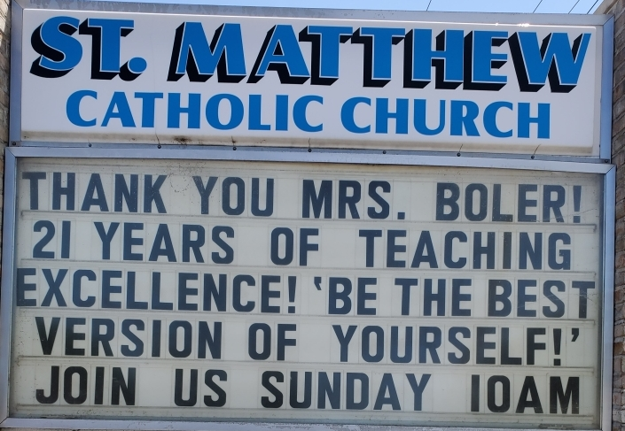
The following is a method that may make creating messages for the marquee sign easier.
THANK YOU MRS. BOLER!
21 YEARS OF TEACHING EXCELLENCE! ‘BE THE BEST VERSION OF YOURSELF!’
JOIN US SUNDAY 10AM

The longest line has 24 letters/characters/spaces
While this example uses the maximum number of characters, it is not very visually appealing.

The yellow shaded box below is a template that can be used to create a message. Type your message idea in all capital letters in Calibri Font size 14 and center the text to see what the message might look like. The text box is set for 24 characters and will wrap. If you change the size of the text box or use a different font or size the message may not fit on the sign.
Examples
JOIN OUR CATHOLIC SUMMER CAMP FOR KIDS! JULY 7-12
CALL 630-469-6300 FOR
INFO AND REGISTRATION!

Sign Request – complete both boxes if you have a different message for each side. This is especially helpful if you want a message in multiple languages.
THIS IS THE SIGN THAT I WANTED TO POST FOR THE ENTIRE WORLD TO SEE!
IS IT NOT THE BEST SIGN IN THE WHOLE WIDE WORLD?
Proposed dates: DATE??? to DATE??? . The sign will stale if not changed regularly.
North-facing Side South-facing Side
LENT
LAS REGISTRACIONES PARA LA FORMACION DE FE
ESTAN ABIERTAS!
HABRA DESCUENTO DEL DIA JULIO 5 – AGOSTO 31
CHILDREN’S
FAITH FORMATION
REGISTER NOW!!!
DISCOUNT
JULY 5 – AUGUST 31

